Product Requirements

**Project**: Healthcare Data Visualization Portal

**Team**: Data Decoders

**Team Members:**

Sai Durga Rohith Kandula - 11610068

Akhil Ayyala - 11697980

Sriya Alugupalli - 11632500

Srikanth Chinta - 11642817

Ajith Kumar Badamalolu - 11652753

# Revision History

|  |  |  |  |
| --- | --- | --- | --- |
| **Date** | **Version** | **Description** | **Author** |
| 09-19-2023 | 1.0 | Software Requirement | Data-Decoders |

**Brief problem statement**

To develop a website, this approach benefits everyone which will help every single person.

We identify the following goals:-

- Easy interaction between a website and the client

- Manage reports

- Focusing on what clients want and need

- Monitoring

This will be carried out using web application where each individual can access information. This project is to develop a digital platform for bind and normal people for better understanding, accessing the information.

# Stakeholders

## “ DATA Decoders” University - Investor and Board of Directors

## The goal and funding of this project, which is being funded by the "Data Decoders" university(UNT), must be approved. The investor must be involved in the product life cycle right away. our may be accomplished by setting up a few meetings and presentations with the investor and board of directors, which will ensure that they are an important part of our project and, consequently, can offer us with many resources if necessary.

## “ DATA Decoders” University - Product owner

## 

## The product owner of AI - Vision verse university is the marketing department. They are in charge of having an idea of what they want to create and communicating this to the development team. The following are some of the duties of the product owner:

## Features are defined.

## Specifies and approves iterations and stories.

## Supports the vision.

## Works with the development team.

## Prioritize your needs.

## Assess the status of the product.

## Blind people

## They must be involved at every step of the process because they will be the product's final users. To collect their information and opinions, surveys, interviews, and focus groups will be used. Before the product is released, a group of carefully chosen blind individuals will test it to make sure that any adjustments need to be made.

## Software Engineering Team

The software engineering team is in charge of tracking and moving the project's life cycle forward. These are just a few of their duties.

* Defining the project's specifications Implementing the project and all of its features.
* Testing software is being done.
* Assigning team members to the many tasks that have been broken up within the project.
* Monitoring the progress of the task carefully.
* Address any faults that cause the life cycle to be delayed.

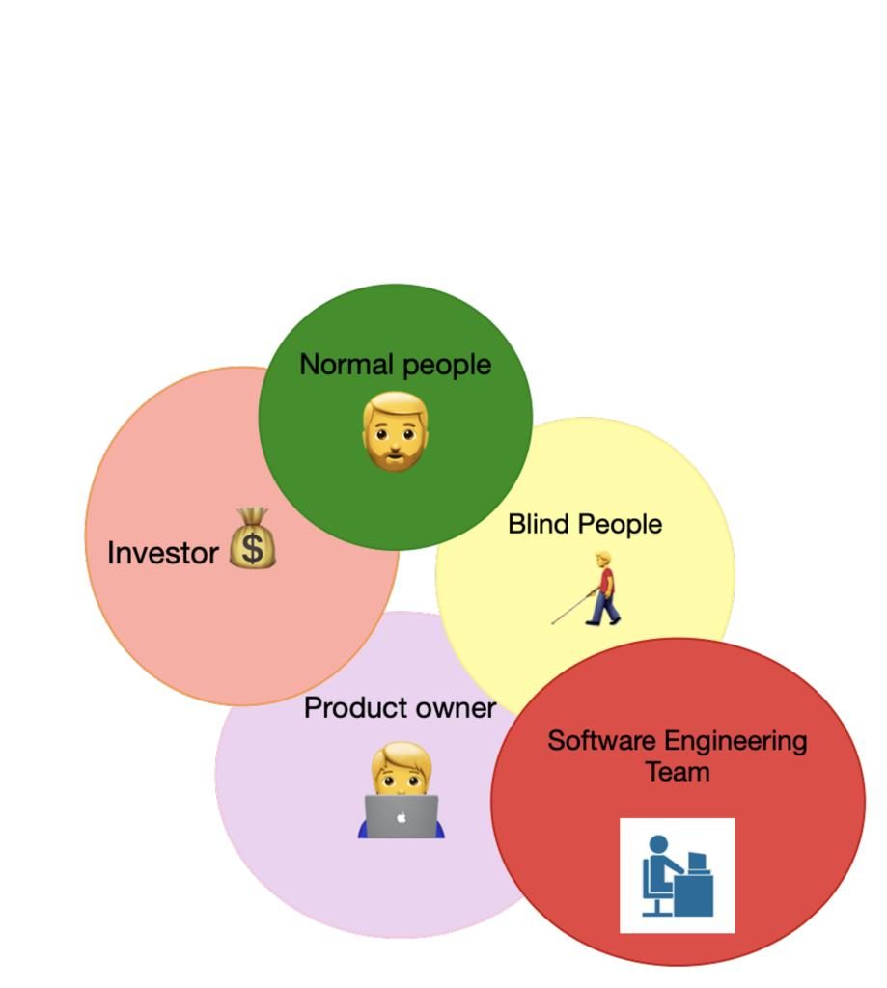

Stakeholders’ relation

## Users

The desired user:

* User must have experience managing files, including downloading and uploading data.
* Must be comfortable using networking and navigating the internet.
* Use a browser that is up to data.

• User must be familiar with keyboard shortcuts and controls in order to browse data.

# System requirements

The project will create a central website for blind people and has the following requirements:

* The project will be programmed in JavaScript; Applications for data visualization can have accessible user interfaces by using frameworks like React and Angular; The project will use JavaScript as its programming language.
* TTS software that converts written text into audio content. These engines can be changed to provide information in a clear and understandable manner.
* A MySQL database shall be used for the project.
* The project must work with the most recent iterations of web browsers.

# Feature requirements

### Functional

|  |  |  |  |
| --- | --- | --- | --- |
| **No.** | **User Story Name** | **Description** | **Release** |
| 1 | **Start** | By selecting the get started button, administrators and users who are blind can access the website. | R1 |
| 2 | **Healthcare CSV Data** | Excel files can be uploaded and set up for use by blind users in data visualizations. | R1 |
| 3 | **Create Data visualization** | Data visualizations will be created/generated from the data that has been uploaded. | R1 |

|  |  |  |  |
| --- | --- | --- | --- |
| 4 | **Investigate Data** | Users who are blind can explore data visualizations by selecting files.  A blind user can navigate between data points, labels, and trends by using a screen reader or keyboard controls. | R1 |
| 5 | **Engage with data** | By choosing files, blind users can explore data visualizations.  Using a screen reader or keyboard controls, a blind user can switch between data points, labels, and trends. | R1 |
| 6 | **Personalize Accessibility Settings** | Allow users to personalize accessibility settings, such as voice preferences and screen reader compatibility. | R2 |
| 7 | **Manage Accounts** | The administrator can create, edit, update, or delete user accounts, including those with accessibility preferences.  The administrator can reset passwords and manage user permissions for the following classes:  1.Patient Name  2. Patient Disease  3. Room Number  4. Number of days admitted  5. Drugs/ Medicines  6. Doctor Name  7. Patient Treatment costs  8.Hospital Staff | R2 |
| 8 | **User Assistance** | Blind Through the system, users can ask for assistance or support.  Administrators are able to provide assistance and support to users. | R2 |
| 9 | **Maintain and Store the Data** | The administrator can add new data visualizations and modify those that already exist in order to keep them current.  An administrator can make data visualizations accessible and compliant with accessibility standards. | R2 |

|  |  |  |  |
| --- | --- | --- | --- |
| 10 | **Data Information Testing** | Administrators perform frequent accessibility testing and compliance checks to ensure that data visualizations follow accessibility guidelines. | R1 |
| 11 | **Data Authentication** | Utilize validation checks when uploading data to ensure that it is accurate and compatible with visualization tools. | R1 |
| 12 | **Data Accessibility**  **Testing** | Automated accessibility tests should be run on uploaded data to identify any potential issues and offer suggestions for improvement. | R1 |

1. **Non-Functional**

### Usability

* + 1. **User Interface**
       - The system ought to offer options for changing the user interface so that blind users can tailor their experience.
       - Given users the option to change their voice preferences and support for screen readers. When designing the user interface, take accessibility into account by establishing a screen reader-friendly, keyboard-navigable, and accessibility-compliant layout.
       - The system must allow for error and have an intuitive user interface.

### Accessibility

* + - * Both people with disabilities and those without shall have access to the system.
      * Ensure compliance with pertinent accessibility standards to ensure an accessible user experience for people with visual impairments.
      * The system should offer different representations of data visualizations to the benefit of users who might have different preferences for consuming data using different perceptions.

### Reliability & Availability

* The system should always provide an accurate user experience, with minimal system downtime and availability of data visualizations as needed.
* Users consistently have access to and availability of the system.
* For the system to deliver trustworthy information to blind users, data accuracy and integrity must be maintained.

### Performance

* Boost the responsiveness of the system to make sure that data visualizations load quickly.
* The system must respond to blind users input extremely quickly to allow blind users to explore and interact with data visualizations in real-time.
* The system must be able to handle peak loads effectively, especially when there is a lot of user activity.
* Achieve quick loading times for data visualizations and other types of data by optimizing the system's functionality to cope with a potential high user volume.

### Security

* The system shall not allow unauthorized access and interception to protect user data
* An administrator must be the only person with access to the system database.
* Strong security measures should be implemented by the system to protect user data and privacy, especially when handling sensitive data.

# Use case diagram

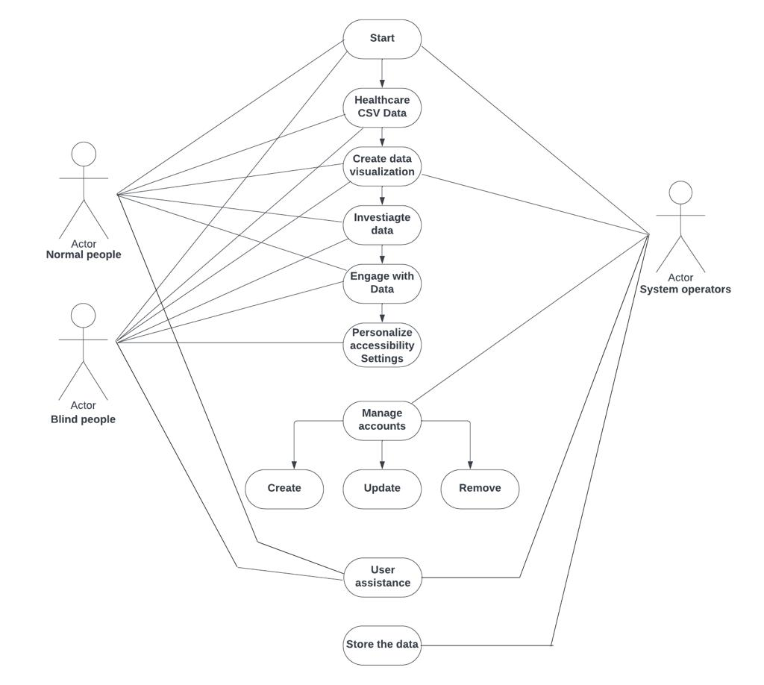

Use Case Diagram

# Use case description

|  |  |
| --- | --- |
| Use Case Number | UC-01 |
| Use Case Name | **Start** |
| Overview | The page will load for the user first. |
| Actor(s) | Users(Blind/Normal), System Operator |
| Pre-condition(s) | * The website is made available to the user. * The user has accessed the website through a URL |
| Scenario Flow | **Main (success) Flow:**  1. By clicking the get started button on the home page, the user or administrator can begin using the website. |
| Alternate Flows | Not applicable |
| Post Condition | The user/admin had access to the page. |

|  |  |
| --- | --- |
| Use Case Number | UC-02 |
| Use Case Name | **Healthcare CSV File** |
| Overview | The user will upload excel files for the visualizations |
| Actor(s) | User(Normal/Blind) |
| Pre-condition(s) | The user must land on the home page. |
| Scenario Flow | **Main(success) Flow:**  In order to create data visualizations, the user must upload files. The data visualizations are generated. |

|  |  |
| --- | --- |
| Alternate Flows | Not applicable. |
| Post Condition | Excel files may be uploaded by the user. |

|  |  |
| --- | --- |
| Use Case Number | UC-03 |
| Use Case Name | **Create Data visualizations** |
| Overview | The system will generate visualizations based on the user selection. |
| Actor(s) | User(Blind/Normal), System Operator |
| Pre-condition(s) | Excel file must be uploaded to the system. |
| Scenario Flow | **Main (success) Flow:**  The user can choose from a list of available visualizations by using the dropdown. |
| Alternate Flows | The dropdown allows the system to access a list of available visualizations. |
| Post Condition | Visualizations are generated. |

|  |  |
| --- | --- |
| Use Case Number | UC-04 |
| Use Case Name | **Investigate Data** |
| Overview | The users will investigate the visualizations |
| Actor(s) | User(Blind/Normal) |
| Pre-condition(s) | Users can browse data visualizations by hovering over them while using key controls to explore them. |
| Scenario Flow | **Main (success) Flow:**  Users can explore data visualizations, and we can browse by hovering over the visualizations while using key controls.(Blind People) |
| Alternate Flows | Not applicable. |
| Post Condition | The content/data points will be shown by the system on the page. |

|  |  |
| --- | --- |
| Use Case Number | UC-05 |
| Use Case Name | **Engage with Data** |
| Overview | Data visualizations will be ready for the users(Blind/Normal) to access. |
| Actor(s) | User(Normal/Blind) |
| Pre-condition(s) | User Should access the portal. |
| Scenario Flow | **Main (success) Flow:**  Key controls and gestures can be used to read out the data visualized. |

|  |  |
| --- | --- |
| Alternate Flows | Not applicable. |
| Post Condition | The system is interactive with the user |

|  |  |
| --- | --- |
| Use Case Number | UC-06 |
| Use Case Name | **Personalize accessibility settings** |
| Overview | System Operator are able to customize accessibility settings for user convenience |
| Actor(s) | User(Blind/Normal), System Operator |
| Pre-condition(s) | Not Applicable |
| Scenario Flow | User can update their preferences. |

|  |  |
| --- | --- |
| Alternate Flows | Not applicable. |
| Post Condition | User Settings can be updated. |

|  |  |
| --- | --- |
| Use Case Number | UC-07 |
| Use Case Name | **Manage Accounts** |
| Overview | The admin will have the ability to manage account   * Update account * Delete account Create account |
| Actor(s) | System Operator |
| Pre-condition(s) | The user needs to be in an admin position to manage accounts. |
| Scenario Flow | 1. **Create User Account**   The user clicks on “Import csv” for the data to be created.   1. **Update user account**   The user can modify the details by selecting the respected column.   1. **Delete user account**   The user can deleted the details by selecting the respected column.  The User must upload the csv file with these details for the data visualization.  1.Patient Name  2. Patient Disease  3. Room Number  4. Number of days admitted  5. Drugs/ Medicines  6. Doctor Name  7. Patient Treatment costs  8.Hospital Staff  After generating the data the user can save their respective data. |

|  |  |
| --- | --- |
| Alternate Flows | Not applicable. |
| Post Condition | * **Create account**   The account will be created and available to users.   * **Update account**   The account details are modified.   * **Delete account**   The account will be permanently erased |

|  |  |
| --- | --- |
| Use Case Number | UC-08 |
| Use Case Name | **User Assistance** |
| Overview | The system will receive assistance requests that are submitted by users. |
| Actor(s) | User(Normal/Blind), System Operators. |
| Pre-condition(s) | System Operators Only have Access and user should have permission to modify. |
| Scenario Flow | * Users who are blind will ask for Assistance to admin. * Administration will grant the Permission for help. |
| Alternate Flows | Not applicable |
| Post Condition | Not applicable |

|  |  |
| --- | --- |
| Use Case Number | UC-09 |
| Use Case Name | **Maintain and store the data (Data Visualization)** |
| Overview | The admin will be able to maintain data visualizations |
| Actor(s) | System Operators |
| Pre-condition(s) | The admin must have the permission to maintain the visualizations. |
| Scenario Flow | **Main (success) Flow:**  The administrator can add new data visualizations and modify those that already exist in order to keep them current. |

|  |  |
| --- | --- |
| Alternate Flows | The dropdown allows the system to select from a selection of available visualizations. |
| Post Condition | The user can upload the excel file. |

**Individual Contributions:**

|  |  |
| --- | --- |
| **Names** | **Contributions** |
| Sai Durga Rohith Reddy Kandula | Focused on defining the project's functional and non-functional requirements, laying out what the system should be able to do (functional) and how it should operate (non-functional), which served as the framework for system development. |
| Sriya Alugupalli | The use case diagram, which illustrates various scenarios and user roles, was the main focus of my work. It shows visually how users interact with the system. |
| Srikanth Chinta | Worked on use case Description and it’s modules. |

|  |  |
| --- | --- |
| Ajith Kumar Badamalolu | Took charge of the project's data collection, conducting research, compiling pertinent information, and creating all project documentation while ensuring accuracy and thoroughness. |
| Akhil Ayyala | Worked on stakeholders for the project. |